Attachment 1 Identification of infective larvae
Parametre | Type infektive larvae
 | Trichostrongylus sp. | Haemonchus sp. | Cooperia sp.
Figure | 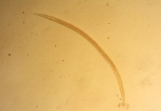 | 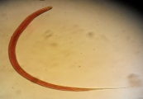 | 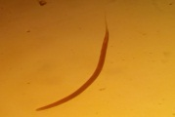
Total (%) | 83.1 | 8.92 | 7.98
Diameter(µm) | 18.87±0,21 | 22.49±1.36 | 33.84±3.55
Lenght (µm) | 653.40±39,74 | 803.30±30.63 | 919.07±5.37
Literature* (µm) | 730±50 | 882.13±102.63 | 1005±123
*Van Wyk dan Mayhew (2013)

