Impact Analysis of The Major Destination Countries’ Non-Tariff Measures (NTM) on The Indonesian Tuna Exports

Oktavina Widya Kristriana
Economics, Bogor Agricultural University, Faculty of Economics and Management Building, 2th floor, Jl. Kamper, IPB Darmaga Campus, Bogor 16680, West Java, Indonesia

Wiwiek Rindayati
Economics, Bogor Agricultural University, Faculty of Economics and Management Building, 2th floor
Jl. Kamper, IPB Darmaga Campus, Bogor 16680, West Java, Indonesia
Phone 62 8111154443; email : wiwiekrinda@yahoo.com

Abstract

Currently, International tradee is hampered in both tariff and non-tariff. Non-Tariff Measures (NTMs) is likely applied by some major trading countries. Sanitary and Phytosanitary (SPS) and Technical Barrier to Trade (TBT) are the most widely applied NTMs policy. Tuna commodities is one of Indonesian potential exports facing NTMs barriers. Some of Indonesian tuna exports major destinations are China, Japan, Thailand, United States, South Korea, Singapore, and Vietnam. This study aims to analyze the export performance and NTMs impact on the Indonesian tuna exports commodities. The methods used are descriptive analysis through inventory approach (coverage ratio and frequency index) and gravity model. The results show that United States as a country imposing highest NTMs and frozen tuna as the most affected commodity group by NTMs effects. The estimation results SPS and TBT affect tuna fish exports with positive coefficient of each 0.011 and 0.015.

Keywords: Gravity model, NTM, SPS, TBT, and Tuna fish

- Introduction

The export growth that has been promoted by international trade is hampered in both tariff and non-tariff. The tariff was applied by World Trade Organization (WTO) in trading commodities all over the world, for both development and developing countries. Various form of tariff has been decreasing through preference agreement of global trade. Non-tariff measures had been being applied by countries by way of protection to domestic producer in order to face import competition with foreign product. [1].
Lately, there are two trends in agricultural sector such as increasing of society consumption and the problem about products originality and its composition. Product safety and sustainable environment in production process are the things people will more concern about and thus, it will make an impact on consumer’s decision on agricultural product purchasing. Even that, their decision of purchasing is not only determined by themselves, makes the important role for non-tariff measures [2]
“Non-tariff measures are generally defined by the measures other than ordinary customs tariff that can potentially impact an economic on international trade of goods, changing in qualities, or prices, or both” [3]. It had been classified by UNCTAD into taxonomy from all relevant measures in international trade. Technically, the regulation has divided in two big categories, such as sanitary and phytosanitary (SPS) and technical barrier to trade (TBT). TBT measures are referring to procedures for assessment of conformity with technical standards (including both requirements and conformity assessment procedure) and technical regulations. As in the case of TBT, SPS are measuring to protect human or animal health and to limit any kind of disease from the importation of goods which may cause damage.
Indonesia has been incorporated in the World Trade Organization (WTO) and should open the domestic market up for other countries and take every consequences of international trade. Every country has different policy for their international trade, and as the exporting country, Indonesia has to meet the requirements imposed by the importing country and maximize the export potential in order to encourage the national trade surplus.
Table 1. Fisheries volume and export value based on main commodities and destination countries of 2011-2012

Countries | Year |  |  |  |  |  |  |  |  |  | Change
Countries | 2011 |  |  |  |  | 2012 |  |  |  |  | 2011/2012
Countries | Volume | Value |  | Volume |  |  |  | Value |  | Volume |  |  | Value
Countries | (ton) | (USD 000) |  | (ton) |  |  |  | (USD 000) |  | % |  |  | %
Japan | 123 830 |  | 806 060 |  | 118 732 |  | 842 118 |  | -4.12 |  |  | 4.47
Shrimp | 37 897 |  | 427 301 |  | 33 521 |  | 372 825 |  | -11.55 |  |  | -12.75
Tunas | 44 604 |  | 174 060 |  | 38 526 |  | 171 203 |  | -13.63 |  |  | -1.64
Crab | 1 149 |  | 12 892 |  | 383 |  | 2 763 |  | -66.67 |  |  | -78.57
United States | 126 931 |  | 1 070 484 |  | 133 476 |  | 1 147 191 |  | 5.16 |  |  | 7.17
Shrimp | 70 059 |  | 615 055 |  | 62 194 |  | 500 307 |  | -11.23 |  |  | -18.66
Tunas | 15 062 |  | 71 374 |  | 14 545 |  | 91 357 |  | -3.43 |  |  | 28.00
Crab | 10 016 |  | 198 319 |  | 4 976 |  | 91 236 |  | -50.32 |  |  | -54.00
China | 242 397 |  | 220 998 |  | 295 486 |  | 284 664 |  | 21.90 |  |  | 28.81
Shrimp | 5 920 |  | 25 432 |  | 6 136 |  | 39 804 |  | 3.65 |  |  | 56.51
Tunas | 711 |  | 1 518 |  | 6 640 |  | 5 684 |  | 833.90 |  |  | 274.44
Crab | 4 379 |  | 16 033 |  | 6 950 |  | 41 622 |  | 58.71 |  |  | 159.60
Others | 563 858 |  | 963 626 |  | 594 304 |  | 1 133 795 |  | 5.40 |  |  | 17.66
Shrimp | 27 527 |  | 97 652 |  | 43 858 |  | 279 302 |  | 59.33 |  |  | 186.02
Tunas | 51 263 |  | 154 159 |  | 113 645 |  | 358 242 |  | 121.69 |  |  | 132.39
Crab | 6 386 |  | 23 756 |  | 14 642 |  | 181 477 |  | 129.28 |  |  | 663.92
Source: Ministry of Marine Affairs and Fisheries (2012)

Tuna is one of the ten potential commodities which tooks a role to encourage Indonesian export. Based on the Ministry of Marine Affairs and Fisheries (2014), the growth of Indonesian fisheries total production reach 3.53% in five years. This achievement were dominated with 269.5 tons of tuna and 381 tons of cakalang, make a note of tuna commodity as one of the great contributor to Indonesian export with USD 515 million. Table 1 shows the top three commodities for fisheries, such as shrimp, tuna, and crab to Japan, China, United States as the major destination countries. The changing value of tuna commodity in 2011-2015 has the greater effect than others, with the value of each 274.44% for China, and 28% for Japan [4].
China, Japan, Thailand, United States, South Korea, Singapore, and Vietnam are the major destination of Indonesian tuna exports. The bigger opportunity to encourage the volume of Indonesian tuna exports are given by the positive growth of the export and the market developing of these countries. This opportunity, however has increasing Indonesian bargaining position by the involvement in many world Associations for Tuna exports such as Western and Central Pacific Fisheries Commission/ WCPFC, Commissions for the Conservation of Southern Bluefin Tuna/ CCSBT and Indian Ocean Tuna Commission/ IOTC.
However, apart from the aim for applying of the trade policy either to cope with market failure or as a protection, NTMs are expected to impact a distortion effect on international trade. Limited access to the market is a new obstacle from applied non-tariff measures by the importing countries in exchange to previous tariff policy [5]. The result of the study shows that even with no protection intention NTM will increase the cost of trade and suppress the small producer in developing countries where the law access and information of regulation most likely hard to do. The trade cost can be increased by two ways. First, the increasing of the fix cost to accustom to product standard and regulation enforced by importing countries. Second, conformity assessment procedures such as testing that will make an addition cost.
Emerging issues regarding SPS and TBT that has been widely applied by importing country as protection can be an obstacle to Indonesian tuna exports. The domestic Associations of Indonesian tuna such as Indonesian Longline Tuna Associations (ATLI), Indonesian Tuna Associations (ASTUIN), Pole and Line and Hand Line Fisheries Associations (AP2HI) and Indonesian Commissions of Tuna (KTI) are taking an important note on tuna industry to face NTM through improvement of quality standard and suppressing the trade cost to meet the importing countries’ standard.
This study aims to analyze whether the impact of non-tariff measures to be obstacle or, in the contrary, create an opportunity for Indonesian tuna exports, and to result new implications policy to encourage the performance of Indonesian tuna exports.

2. Methods

Descriptive analysis used as a general overview of tuna exports policy and NTMs applied by destination countries. Inventory approach used to analyze the applied NTM with frequency index and coverage ratio as indicators.
Frequency index is only used to measure the presence of NTMs and summarize the percentage of the product where NTMs are applied as explained by Fugazza (2013) [3]. Frequency index shows the percentage of import transaction involved in NTMs for exporting countries, whereas coverage ratio shows the percentage of trade subjects affected by NTMs and also measures the importance of NTMs over all. Both indicators are measures as follows:

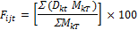

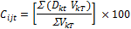
Where:
F_{ijt} = Frequency index of exporting country i to importing country j on year t (%)
D_{kt} = dummy variables which indicates the presence or absence of one or more NTM on product k on year t
M_{kT} = volume of product k with the total years of all imported volume
C_{ijt} = Coverage ratio exporting country i to importing country j on year t (%)
V_{kT} = value of product k with the total years of all imported value
j = importing country
i = exporting country
k = import product
t = year of applied NTMs
T = total years of total imports to destination country

The value of frequency index and coverage ratio are in range of 1-100. The smaller number of frequency means fewer NTMs imposed by the importing country and bigger number means otherwise. The smaller number of coverage ratio means fewer product coverage affected by NTMs and vice versa with the bigger number.
Gravity model is the tool to analyze the impact of NTMs on export using export value of Indonesian tuna to destination countries. The independent variable used are GDP per capita for importing countries, population of importing countries, economic distance, NTMs imposed by importing countries (SPS and TBT), and real exchange rate in period of 2009-2013.
The model used in this study refer to gravity model by Fontagne et al (2005) [5], using coverage ratio approach as independent variable. The model is formulated as follows:

Where:
EX_{ijt} = export value of Indonesian tuna to country j on year t (million USD)
POP_{ijt} = population of importing country j on year t (people)
GDPC_{jt} = GDP per capita of importing country j on year t (million USD)
EDIST_{ijt} = economic distance between exporting country j and Indonesia (km)
RER = real exchange rate of Indonesia to importing country j on year t
CR TBT_{ij} = coverage ratio TBT imposed by importing country j on Indonesian tuna on year t (%)
CR SPS_{ijt} = coverage ratio SPS imposed by importing country j on Indonesian tuna on year t (%)

3. Results

3.1 Indonesian Tuna Exports on the Major Destination Countries

Lately, the trade balance of Indonesian tuna commodities to the major destination country shows a progress on its performance, make a note of tuna as a potential commodity to encourage the trade balance. As the second biggest exporting country for tuna exports and with its potency of marine are the big opportunity to encourage the performance.

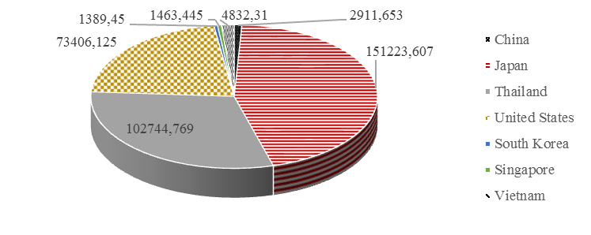
Source: UNCOMTRADE (2015)

Figure 1. Export value of Indonesian tuna to destination country on year 2013 (000 USD)

The illustration shows Japan as the destination country with the highest value of Indonesian tuna exports with 151 151 223.6 million USD on 2013, followed by Thailand with 102 744.769 million USD, and United States with 13406.125 USD (Figure 1). During 2009-2013, the Indonesian tuna exports has been dominated by Japan as the destination country. Japan has a high level of fish consumption that push the demand of tuna importation.
The performance of tuna commodities shown by the trade balance of tuna in period of 2009-2013 to the destination country (Table 2). The table shows a surplus in almost all destination countries except for China on 2010-2011, and South Korea on 2013. The deficit on South Korea is the only one occurred on 2013, whereas the rest had a surplus for its export.

Table 2. Trade Balance of Indonesian tuna exports to The Major Destination Countries on 2009- 2013 (000 USD)
Destination Country | Year | Export | Import | Trade Balance
China | 2009 | 2 411.01 | 1 388.99 | 1 022.01
 | 2010 | 1 220.60 | 3 597.75 | -2 377.16
 | 2011 | 1 523.21 | 8 805.47 | -7 282.26
 | 2012 | 5 684.32 | 607.23 | 5 077.10
 | 2013 | 2 911.65 | 0.00 | 2 911.65
Japan | 2009 | 130 813.28 | 6 762.34 | 124 050.94
 | 2010 | 159 927.99 | 7 956.15 | 151 971.84
 | 2011 | 174 059.81 | 17 701.44 | 156 358.37
 | 2012 | 171 203.43 | 10 713.49 | 160 489.95
 | 2013 | 151 223.61 | 5 125.99 | 146 097.62
Thailand | 2009 | 24 783.09 | 3 563.49 | 21 219.60
 | 2010 | 16 293.55 | 7 847.32 | 8 446.24
 | 2011 | 36 618.83 | 6 194.48 | 30 424.35
 | 2012 | 111 471.01 | 2 529.82 | 108 941.20
 | 2013 | 102 744.77 | 1 149.06 | 101 595.71
United States | 2009 | 71 382.85 | 748.86 | 70 633.99
 | 2010 | 75 763.17 | 122.02 | 75 641.15
 | 2011 | 71 519.46 | 740.91 | 70 778.55
 | 2012 | 91 619.96 | 0.00 | 91 619.96
 | 2013 | 73 406.13 | 106.40 | 73 299.73
South Korea | 2009 | 1 503.72 | 45.97 | 1 457.76
 | 2010 | 2 103.69 | 158.71 | 1 944.98
 | 2011 | 3 076.24 | 131.36 | 2 944.88
 | 2012 | 5 181.82 | 154.05 | 5 027.78
 | 2013 | 1 389.45 | 1 506.83 | -1 17.38
Vietnam | 2009 | 9 830.67 | 35.86 | 9 794.81
 | 2010 | 8 940.72 | 85.68 | 8 855.04
 | 2011 | 7 688.55 | 58.40 | 7 630.15
 | 2012 | 7 704.51 | 91.52 | 7 612.99
 | 2013 | 4 832.31 | 0.00 | 4 832.31
Singapore | 2009 | 4 459.90 | 227.74 | 4 232.16
 | 2010 | 4 409.24 | 63.18 | 4 346.07
 | 2011 | 1 825.08 | 12.94 | 1 812.14
 | 2012 | 1 534.37 | 0.01 | 1 534.36
 | 2013 | 1 463.45 | 0.00 | 1 463.45
Source : UNCOMTRADE 2015 (calculated)

The deficit of tuna exports to South Korea on 2013 is an impact of the deficit occurred on frozen tuna exports with 5.46 USD and prepared or preserved tuna with 226.08 USD (Table 3). Since 2010, prepared or preserved tuna has always been deficit with an increasing number and so it decreases the growth of tuna exports. On 2013, the highest surplus for prepared or preserved tuna is 43 674.69 USD to Japan. The country is also has the highest surplus for fresh tuna with 66 390.6 USD, while the frozen tuna has the highest export of 68 933.8 USD to Thailand.

Table 3. Trade Balance of Indonesian tuna exports on The Major Destination Countries Based on Subgroup on 2010- 2013 (000 USD)
Destination Country | Subgroup | Year
Destination Country | Subgroup | 2009 | 2010 | 2011 | 2012 |  | 2013
China | Fresh | 822.66 | 149.32 | 416.16 |  | 192.80 |  | 26.85
 | Frozen | 152.30 | -2 474.57 | -7 571.26 |  | 5 370.14 |  | 2 718.70
 | Prepared or preserved | 47.05 | -51.91 | -127.15 |  | -485.85 |  | 166.10
Japan | Fresh | 74 080.88 | 93 207.11 | 73 746.83 |  | 61 602.90 |  | 66 390.58
 | Frozen | 4 702.77 | 14 288.02 | 26 796.88 |  | 39 455.25 |  | 36 032.36
 | Prepared or preserved | 4 5267.29 | 44 476.72 | 55 814.66 |  | 59 431.80 |  | 43 674.69
Thailand | Fresh | 1 814.13 | 116.56 | 649.65 |  | 722.40 |  | 106.47
 | Frozen | 1 3417.48 | -32.21 | 13 321.76 |  | 76 341.89 |  | 68 933.83
 | Prepared or preserved | 5 987.99 | 8 361.89 | 16 452.94 |  | 31 876.90 |  | 32 555.42
United | Fresh | 7 984.85 | 5 778.36 | 6 249.27 |  | 5 037.28 |  | 2 653.45
States | Frozen | 16 104.15 | 17 660.02 | 18 740.34 |  | 37 249.05 |  | 30 342.20
 | Prepared or preserved | 46 545 | 52 202.77 | 45 788.94 |  | 49 333.63 |  | 40 304.07
South | Fresh | 757.07 | 347.75 | 174.58 |  | 371.39 |  | 114.35
Korea | Frozen | 695.121 | 1 627.48 | 2 736.85 |  | 4 788.86 |  | -5.64
 | Prepared or preserved | 5.56 | -30.25 | 33.44 |  | -132.47 |  | -226.09
Vietnam | Fresh | 4 712.36 | 1 135.87 | 2 179.38 |  | 1 543.81 |  | 95.26
 | Frozen | 4 929.42 | 7 352.57 | 5 426.67 |  | 5 822.56 |  | 4 737.05
 | Prepared or preserved | 153.03 | 366.60 | 24.09 |  | 246.61 |  | 0
Singapore | Fresh | 1 641.36 | 735.10 | 307.46 |  | 279.47 |  | 433.52
 | Frozen | 2 325.49 | 3 369.48 | 1 329.52 |  | 995.90 |  | 746.96
 | Prepared or preserved | 265.30 | 241.48 | 175.15 |  | 258.98 |  | 282.95
Source: UNCOMTRADE 2015 (calculated)

3.2 Non-tariff Measures (NTMs) Applied on Indonesian Tuna Exports
Lately, NTM has been an important issue on international trade. The tendency of public concerns to product safety and the process that related to of an environment sustainability are the factors of why some countries are imposing NTMs in order to improve the national welfare.
Table 4. Applied of NTMs’SPS and TBT on Indonesian tuna exports on major destination countries on 2002- 2013
Country | SPS | TBT | Total
China | 51 | 3 | 54
Japan | 40 | 7 | 47
United States | 15 | 66 | 81
Thailand | 44 | 6 | 50
South Korea | 11 | 13 | 24
Vietnam | 2 | 0 | 2
Singapore | 0 | 0 | 0
Total | 163 | 95 | 258
Source: WTO 2015
SPS and TBT are NTMs that mostly applied on fisheries subsector. Table 4 shows the number of imposed SPS and TBT by the destination countries for Indonesian tuna exports on 2002-2013. As shown on table 4, Singapore is the only country didn’t impose SPS and TBT. SPS has been imposed with a higher number than TBT for most of the destination country. Whereas United States has the highest imposed TBT for the tuna exports.

United States occurs as destination country that imposed NTM the most, with 15 SPS measures and 66 TBT measures, in total of 81 measures. The measures of TBT that mostly imposed are food standard including 28 measures production standard processing, and 26 measures of labeling. China occurs as the second highest country on imposing NTM with the total of 54 measures. Most of SPS measures imposed by China concerning on human’s health, and all the 3 TBT measures imposed for labeling. Thailand had imposed 44 measures of SPS and 6 TBT measures. Of 40 SPS measures, 38 imposed concerning on both safety food standard and human’s health. Japan had imposed 47 measures with 40 measures of SPS, where most of all concerning on safety food standards, human health, and maximum residue limits (MRLs).
SPS and TBT imposed in destination countries are composed in any measures. The SPS measures imposed the most are safety food standard and human health, while for TBT concerning for labeling.

3.3 Frequency index and Coverage ratio
The inventory approach is used to measure the NTM imposed by some countries. It contains a simple measurement using frequency index and coverage ratio as the indicators. Frequency index is used to calculate the presence of NTM and the percentage of the product affected by NTM. Coverage ratio is used to measure the percentage of trade subject affected by NTM on importing countries [3].

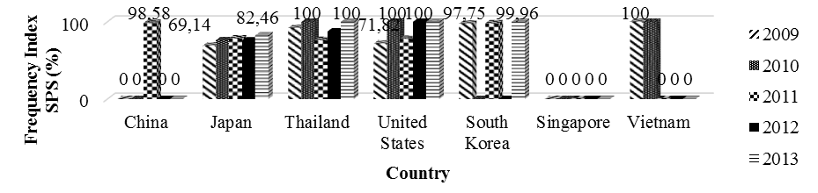
Source: Based on calculation 2015

Figure 2. Frequency index SPS on Indonesian tuna exports to destination countries on year 2009- 2013

The frequency index on 2009-2013 shows a pretty high number for tuna exports affected by SPS, in range of 69-100%. Figure 2 shows Japan, Thailand, and United States that has been consistency imposing SPS on tuna commodities for five years. SPS imposed in Japan on 2010 at 69.14% and reach at 82.46% on 2013. For Thailand has a fluctuative trend of SPS imposed, where it goes down at 76.43% then up again at 100% point on 2013. For United States the SPS consistency imposed at 100% point on 2010, 2012, and 2013. South Korea has a very sharp fluctuative value, where SPS was highest imposed on 2009, 2011, and 2013 at 97.75%, 98.13%, and 99.6% in contrast on 2010 and 2012 when no SPS had imposed.
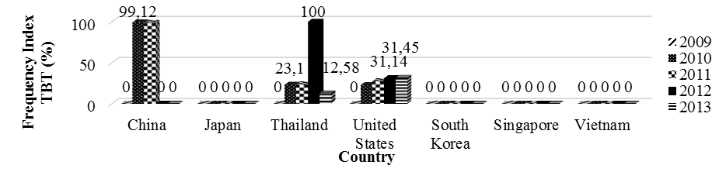

Source: Based on calculation 2015

Figure 3. Frequency index TBT on Indonesian tuna exports to destination countries on year 2009- 2013

Figure 3 shows that frequency index for TBT has the lower value than for SPS. Thailand and United States happened to be countries that consistency imposing TBT on 2010-2013. In five years, China only imposed TBT for two years, at 99.18% on 2010 and 98.58% on 2011. The highest number of TBT imposed by Thailand was on 2012 that reach the 100% point. For United States shows increasing value from 22.67% on 2010 to 31.45% on 2013. Whereas, the rest destination country such as Japan, South Korea, and Vietnam had not imposed TBT measures for Indonesian tuna exports.

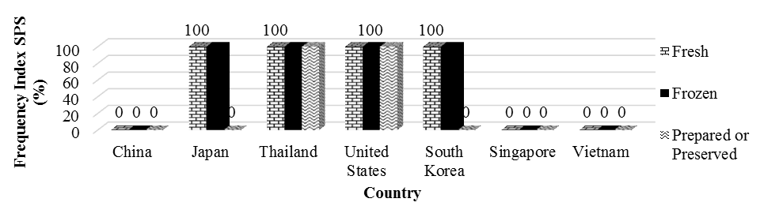
Source: Based on calculation 2015

Figure 4. Frequency index SPS on Indonesian tuna exports to destination countries on year 2013 according to group commodity

The composition of SPS imposed on 2013 as on frequency index of figure 4 shows uniformity at 100% for Japan, Thailand, United States, and South Korea. SPS imposed by Thailand and United States on fresh tuna, frozen tuna, and prepared or preserved tuna at 100% for the three. It is related to the SPS frequency index on tuna commodities on 2013 that reach the point of 100%. Both Japan and South Korea have similar characteristic, where the fresh and frozen tuna has 100% value of SPS frequency index even though those have a different value of total frequency index.
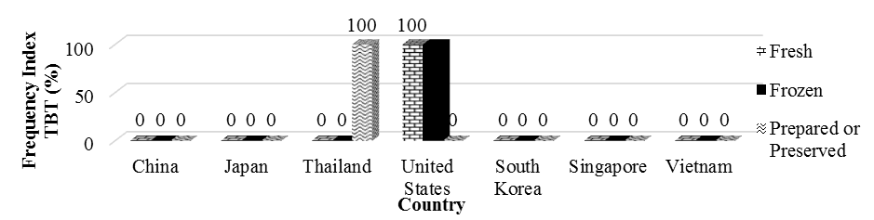
Source: Based on calculation 2015
Figure 5. Frequency index TBT on Indonesian tuna exports to destination countries on year 2013 according to group commodity
Figure 5 shows the composition of TBT on 2013. Related to Figure 3 where the TBT is only imposed by Thailand and United States, so only the value of both occurred on the graphic. Japan had imposed only TBT for prepared or preserved tuna whereas United States had imposed TBT on fresh and frozen tuna.
Other indicator used in inventory approach is coverage ratio. A higher value of coverage ratio shows the higher impact of NTM imposed by destination countries on the importing product. In contrast with frequency index of SPS that most likely high, the coverage ratio of Indonesian tuna exports has a various value on each countries.

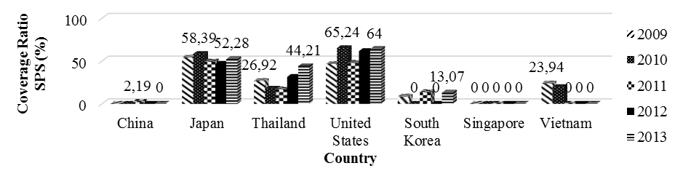
Source: Based on calculation 2015

Figure 6. Coverage Ratio SPS on Indonesian tuna exports to destination countries on year 2009- 2013

Based on Figure 6, the SPS imposed consistency on United States, Japan, and Thailand on 2009-2013. The highest value on United States occurred on 2010 at 65.24% then decreased to 64.00% on 2013. On 2012, Thailand had 46.77% coverage ratio and increased to 52.28% on 2013. South Korea only imposed SPS on 2009, 2011, and 2013 while China has a lowest percentage of SPS on 2011 at 2.19 %.
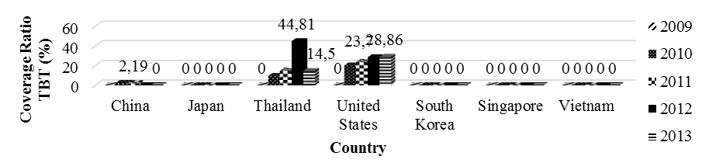

Source: Based on calculation 2015
Figure 7. Coverage Ratio TBT on Indonesian tuna exports to destination countries on year 2009- 2013

Coverage percentage of Indonesian tuna effected by TBT on 2009-2013 shown on Figure 7. United States has a constant increasing till 28.86% on 2013. On 2012, Thailand had a high coverage ratio at 44.81%, as an impact of higher export value than previous and the next year. Whereas, Japan, South Korea, and Vietnam didn’t impose any TBT on 2009-2013.

The diversity on SPS coverage ratio value specifically shown by Figure 8. The frozen tuna has a different value for Japan, Thailand, United States, and South Korea. The wider coverage of SPS occurred on United States at 100% point for both fresh and prepared or preserved tuna and 42.45% for frozen tuna. So did Thailand reach 100% point on fresh and prepared or preserved tuna, and 34.72% for frozen tuna. Both Japan and South Korea didn’t impose SPS on prepared or preserved tuna, but has 100% point of coverage on fresh tuna.

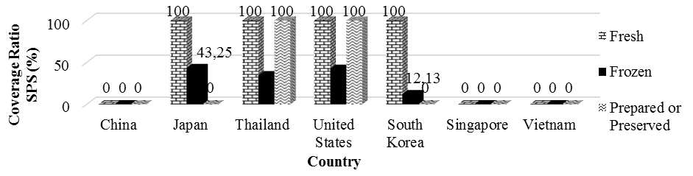
Source: Based on calculation 2015

Figure 8. Coverage ratio SPS on Indonesian tuna exports to destination countries on year 2013 according to group commodity

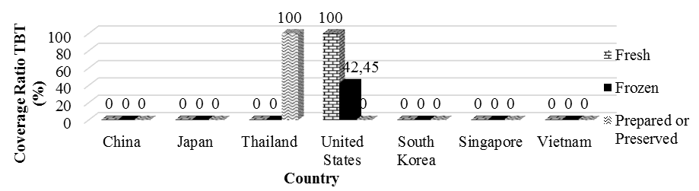
Source: Based on calculation 2015

Figure 9. Coverage ratio TBT on Indonesian tuna exports to destination countries on year 2013 based on commodity

Based on the Figures 9, we can conclude that on 2009-2013, every destination country had imposed NTM except for Singapore. SPS is imposed by most of the destination countries while TBT is only imposed by Thailand and United States on some product of Indonesian tuna exports. United States has a higher value of imposing NTM for both frequency index and coverage ratio. Fresh tuna was the commodity that affected the most by NTM, with the frequency index at 100% on all countries imposing SPS and TBT. The lower value of product affected by NTM is prepared or preserved tuna. The percentage of frequency index shows the high frequent of NTM imposed by the destinations country on Indonesian tuna exports.

3.4 The Impact of NTMs on Indonesian Tuna Exports to The Major Destination Countries

The impact of NTMs (SPS and TBT) on Indonesian tuna exports is discussed on this section. Impact analysis start with the explanation of gravity model testing to result a BLUE (Best Linier Unbiased Estimator) estimation, and to analyze the factors affecting Indonesian tuna exports. The final step is to analyze the impact of SPS and TBT with the model result.

3.4.1 Model Testing

The estimation on table 5 results R-squared at 98.8%. The value means that 98.9% of Indonesian tuna exports can be explained by the variables of GDP per capita of importing countries, population of importing countries, the economic distance between Indonesia and the importing country, coverage ratio of SPS, and coverage ratio of TBT, while the rest of 1.1% be explained by other factors outside the models.

Table 5. The result of model estimation of SPS and TBT impact

Variable | Coefficient | Prob.
C | 468.5537 | 0.0000
GDP per capita | 2.363025 | 0.0007*
Population | -25.9055 | 0.0000*
Economic Distance | -0.9882 | 0.0089*
Real Exchange Rate | 0.049087 | 0.8623
CR SPS | 0.011215 | 0.0048*
CR TBT | 0.015269 | 0.0136*
R-squared |  | 0.989646
Prob(F-statistic) |  | 0.000000
Note: *) significant at 5%

3.4.2 Factors Affecting Indonesian tuna exports Commodities

From the estimation on table 3, there were some variables affecting Indonesian tuna exports. The factors are GDP per capita of importing countries, the population of importing countries, economic distance, and NTMs in the measures of coverage ratio of SPS and TBT.
GDP per capita of importing countries is representing the purchasing power of goods and services in some countries. The estimation results at 5% with the coefficient of 2.363. It means that the increasing of GDP per capita of importing country at 1% will increase Indonesian tuna exports at 2.363%, ceteris paribus. Based on economic theory, GDP per capita has a positive relation to bilateral trade. The increasing of GDP per capita of importing country will increase an absorption capacity that push the import demand. The model result is consistent with the hypothesis and the theory.
The population of importing countries significantly affects the tuna exports at 5% with a negative coefficient. It indicates that the decreasing at 1% on importing countries’ population will increase the Indonesian tuna exports at 25.9%, ceteris paribus. This condition is contrast with the hypothesis and economic theory which explains that the population of importing countries positively affecting the export value. The result on this study is similar with Tilova (2013) [6] that results the negatively significant effect of population of importing country on the export value.
The contrast results is caused by the tuna commodities that is used as raw material on manufacturing industry than being consumed directly. Most of the destination countries for Indonesian tuna exports are the exporting country of prepared or preserved tuna with a large share such as China, Vietnam, and Thailand. Those countries had proceed the Indonesian fresh tuna to be re-exported to others importing country. Besides, there was another substitution consumption for tuna such as salmon that causes a negative coefficient. For Japan only, there was supposition of decreasing level of consumption as the impact of changing composition of population that dominated by adults and elderly. These have given a significant impact to variable of population on the model, with Japan as the first major destination country on 2009-2013.
The variable of economic distance indicates export cost (transportation cost) spent on trading activity. The estimation results that the economic distance has a significant effect at 5% with a negative coefficient at 0.988. It means that the further distance with the destination countries at 1% will decrease the value export at 0.988%, ceteris paribus. The negative coefficient is consistent with the gravity theory where the distance affecting interaction of two objects. The further the distance are, the higher the transportation cost for the trading commodities. The increasing on transportation cost then will cause a decreasing on export value of Indonesian tuna commodities to the major countries.
For real exchange rate variable, the result shows a negative coefficient with the probabilities more than 5%. It means that real exchange rate of rupiah to importing countries’exchange rate hasn’t significantly affecting the Indonesian tuna exports. This result is similar with the study by Dahar (2014) [1]. This could be explained because the major destination country for Indonesian tuna exports are mostly categorized on highly income. A shock on exchange rate will not affect the society’s purchasing power on import product.
The estimation results are consistent with the hypothesis of this study that NTMs affecting the Indonesian tuna exports value. The NTMs impact is measured by coverage ratio approach for both SPS and TBT. The coverage ratio of SPS and TBT on the models show a significant effect of 5% with the positive coefficient at 0.011 and
0.015. It means that when increasing coverage ratio occurs at 1%, will increase the Indonesian tuna exports at the point of 0.011% and 0.015%.

3.5 Impact Analysis of The Major Destination Countries’ NTMs on Indonesian Tuna Exports

NTMs imposed by some countries are based on some factors relating to economic issue, environment, or so the health. They are imposed in order to protect society to ensure the welfare and improving the prosperity of a country. SPS and TBT are the import measures that being imposed the most on various sectors in WTO countries, including Indonesia.
SPS measures to protect human’s life, animal, plant, health, and environment, while TBT is applied to handle a technical regulation and conformity assessment procedures [3]. The WTO regulation allows the imposing of SPS and TBT if it is based on important reason relating to protection, health, and safety for human, animal, plant, and environment. The regulation is also allowed to improve quality, packaging, labeling, and product standard.
Both coverage ratio of SPS and TBT on the models show the significant effect of 5% with the each value of 0.011 and 0.015. It means that SPS and TBT are affecting the Indonesian export commodities even though with low elasticity value.
The positive coefficient for both variables shows that the imposing of SPS and TBT are not always negatively affecting the trade. SPS positive results on coverage ratio is similar with the study by Crivelli (2012) [7]. It can not be denied that imposing SPS will provide information to consumer about the safety of the product. If the SPS measured is affecting more that the increasing trade cost, the share of consumer market will increase. This increasing of share market will make an impact through increasing volume of trade for the producer who managed to overcome the fixed cost for entering the market.
The positive coefficient of TBT is also similar with the study by Shah (2014) [8]. The technical regulation had encouraged the exchange of goods through compatibility increases and product utility. Furthermore, the imposing of TBT had improved the consumer’s welfare through implementation of safety standard and food safety.
The study by Chen et al (2008) in Streamlining Non-Tariff Measures: Toolkit for Policy Maker [9] results that the quality standard and labeling has a positive impact on volume and coverage export, while certification procedure has the negative impact. The positive impact is occurred through decreasing of uncertainty and increasing the consumer’s willingness to pay as an impact of increasing quality standard. Furthermore, the standard has ensured the compatibility of a product and decreasing the coordination failure between producers. On other side, the needs of checking and certification procedure affects the increasing trade cost.
The importance of NTMs can be known through its impact on the international trade. The results that shown a positive on both measures has proven that Indonesian has been able to meet the standard and regulation applied by the major countries of Indonesian tuna exports. It is believed to be related to the role of tuna Associations to support the development of Indonesian tuna industrial. The existence of the Associations such as ASTUIN, ATLI, and AP2HI has been able to provide the facility (such as armada and after fishing units) and the modal to support an easier access for the producer so that they can be able to suppress the increasing trade cost as the impact of meeting the importing countries’ standards. Furthermore, the participation of Indonesia in many international Associations is also affecting the bargaining power and share market on international trade to be able to compete and being one of the biggest tuna exporter of the world.

4. Conclusion

Based on the explanations on the previous sections, there are some conclusions. First, Indonesian tuna trade on 2009-2013 shows a good performance as can be seen on the positive balance trade. The frozen tuna is the commodity to be exported the most, and the biggest export flows goes to Japan.
Second, SPS and TBT by the major destination countries are imposed in all tuna commodities. Based on coverage ratio and frequency index value, fresh tuna is the commodity that affected the most. NTMs that mostly applied is SPS, and United States occurs as the major destination country that imposing NTMs (SPS and TBT) the most.
Third, GDP per capita of importing country, the population of importing country, and economic distance are the factors affecting Indonesian tuna exports. Real exchange rate has no significant effect. SPS and TBT measured by coverage ratio approach are significantly affecting Indonesian tuna exports on the major destination countries with the each coefficient of 0.011 and 0.015.
The positive impact of NTMs resulted by this study shows Indonesian as one of the tuna producer has been able to manage the trade barriers. The tuna producers, in participation of various associations have been able to maximize the potency through utilization and suppress the trade cost and make NTMs into opportunities. To see this phenomenon, the government is expected to give full support through providing easy access for quality and health certification; completing supporting facilities for pra and post process with addition incentives (special incentives to increase export and addition incentives for selected machinery and equipment); deregulation by reducing the regulatory barriers such as limit entry, limit input, or limit market to create the condusive business situation (that will decrease the price and improve quality and innovation); maximizing the tuna processing industry to improve the product competitiveness through revitalization of fishery product processing industry; and conduct an intensive socialization in order to improve the quality of human resources in fisheries according to the international standards of STCW-F (Standards Training Certification and Watchkeeping for Fisheries).

References

- Dahar, Darmiati. Impact of analysis policy non tariff measures on the performance of export horticulture Indonesia to the country ASEAN +3. [Thesis]. Bogor: Bogor Agricultural University; 2014.
- Boza, Sofia. Sanitary, Phytosanitary, and Technical Measures in Agri-food Trade. Chile: University of Chile. 2013.
- Fugazza, Marco. The Economical Behind Non-tariff Measures: Theoritical Insights and Empirical Evidence. Geneva: UNCTAD; 2013.
- Ministry of Marine Affairs and Fisheries. Marine and Fisheries in Item 2013. [Bulletin]. Available on: http://www.statistik.kkp.go.id
- Fontagne L., Mimouni M., Pasteels J-M. Estimating The Impact of Environmental SPS and TBT on International Trade. Geneva: International Trade Center (UNCTAD-WTO); 2005.
- Tilova, Reni. Analysis factors affecting demand Indonesian coal in four country of export the largest. . [Undergraduate Thesis]. Bogor: Bogor Agricultural University.; 2012.
- Criveli P, Groschl J. The Impact of Sanitary and Phytosanitary Measures on Market Entry and Trade Flows. [Working Paper 2012]. Geneva: Universite de Geneve; 2012.
- Shah A, S.M. Ali. 2014. The Impact of Technical Barrier to Trade on Pakistan Industry. Pakistan Science Journal Vol. 66. Pakistan. Cadot O, Malouche M, Saez, S. Streamlining Non-Tariff Measures: A Toolkit for Policy Maker. Washington DC: The World Bank; 2012. p.144-145.

